pBiology, Castle View High School Name: _______________________________________________  
Jason R Mayberry, PhD

**Ionic and Covalent Bonds**

|  |  |  |  |  |  |  |  |  |
| --- | --- | --- | --- | --- | --- | --- | --- | --- |
| **Atomic Number** | **1** |  |  |  |  |  |  | **2** |
| **Atomic Symbol** | **H** |  |  |  |  |  |  | **He** |
| **Name** | **Hydrogen** |  |  |  |  |  |  | **Helium** |
| **Valence Electrons** (*When Neutral*)  (See Hint 1) |  |  |  |  |  |  |  |  |
| **Charge** if forms ions; N.A. if it won’t.  (See Hint 2) |  |  |  |  |  |  |  |  |
| **Number of Covalent Bonds** it will form; N.A. if it won’t. (See Hint 3) |  |  |  |  |  |  |  |  |
| **Atomic Number** | **3** | **4** | **5** | **6** | **7** | **8** | **9** | **10** |
| **Atomic Symbol** | **Li** | **Be** | **B** | **C** | **N** | **O** | **F** | **Ne** |
| **Name** | **Lithium** | **Beryllium** | **Boron** | **Carbon** | **Nitrogen** | **Oxygen** | **Fluorine** | **Neon** |
| **Valence Electrons** (*When Neutral*)  (See Hint 1) |  |  |  |  |  |  |  |  |
| **Charge** if forms ions; N.A. if it won’t.  (See Hint 2) |  |  |  |  |  |  |  |  |
| **Number of Covalent Bonds** it will form; N.A. if it won’t. (See Hint 3) |  |  |  |  |  |  |  |  |
| **Atomic Number** | **11** | **12** | **13** | **14** | **15** | **16** | **17** | **18** |
| **Atomic Symbol** | **Na** | **Mg** | **Al** | **Si** | **P** | **S** | **Cl** | **Ar** |
| **Name** | **Sodium** | **Magnesium** | **Aluminum** | **Silicon** | **Phosphorous** | **Sulfur** | **Chlorine** | **Argon** |
| **Valence Electrons** (*When Neutral*)  (See Hint 1) |  |  |  |  |  |  |  |  |
| **Charge** if forms ions; N.A. if it won’t.  (See Hint 2) |  |  |  |  |  |  |  |  |
| **Number of Covalent Bonds** it will form; N.A. if it won’t. (See Hint 3) |  |  |  |  |  |  |  |  |

* **Hint 1**: The number of electrons in the outermost shell. Find the row the atom is on, then starting at the left hand side of that row, count the number of spaces up to and including the atom on that row (but ignoring the middle two blocks – the d and f subshells), the number you end with is the number of valence electrons.
* **Hint 2**: Consider how many electrons the atom needs to gain or lose to satisfy the octet rule; adding electrons makes an atom negative (anionic); losing electrons makes it positive (cationic). Ions don’t generally form if the charge is ±3 or greater.
* **Hint 3**: Atoms gain electrons “free of charge” when they share electrons – every electron shared is an electron thus gained. However, atoms will only form covalent bonds if they have enough valence electrons to form the needed number of bonds to satisfy the octet rule by sharing. Atoms can form any number of single, double, and triple bonds with appropriate atoms to satisfy their bonding needs. Some atoms will have electrons left-over (i.e. not involved in forming bonds) after they satisfy their octet.

**Part 2 Directions – For each question below:**

1. **Draw molecules using the atoms indicated. Be sure to use the modified Lewis-Dot structures for Ionic Bonds (using brackets and charges), and dashes ( – ) for covalent bonds.**
2. **Write down the simplified chemical formula (i.e. no dashes, electrons, or charges; just symbols and subscripts)**
3. One Group 1 (except Hydrogen) atom and One group 17 atom.
4. One Group 2 atom and One group 16 atom.
5. Any number of group 1 atoms (excluding Hydrogen) with any number of group 16 atoms.
6. Oxygen and any number of atoms from group 17.
7. A carbon atom (C, #6), with a **single** bond to an Oxygen atom (O, #8), and as many Hydrogen atoms (H, #1) as you need.
8. A carbon atom (C, #6), with a **double** bond to an Oxygen atom (O, #8), and as many Hydrogen atoms (H, #1) as you need.
9. A carbon atom (C, #6), with a **double** bond to a Nitrogen atom (N, #7), and as many Hydrogen atoms (H, #1) as you need.
10. A carbon atom (C, #6), with a **triple** bond to a Nitrogen atom (N, #7), and as many Hydrogen atoms (H, #1) as you need.
11. Create three different molecules comprised of at least 5 Carbon (C, #6) atoms, and at least one Nitrogen (N #7), one Oxygen (O, #8), and one Hydrogen (H, #1) atoms (but you may use as many of each as you want/need). Check your work by making sure that each atom in your molecules satisfies the octet rule. Hint: Begin with a chain (or ring) of carbon atoms bound to each other, then add the other atoms as needed/desired.
    1. First proposal
    2. Second Proposal
    3. Third Proposal

|  |  |
| --- | --- |
| Part 3: Find the Error in each of the Molecules Below.   * Circle each error. * Write a brief description of what the error is. | Things to look for:   1. Is each atom forming the right type of bone (ionic or covalent)? 2. If it is forming an ionic bond:    1. is the charge shown correct?    2. Does it show the correct number of valence electrons? 3. If it is forming a covalent bond:    1. Does it have the correct total number of bonds?    2. Does it have the correct total number of electrons? |

1. 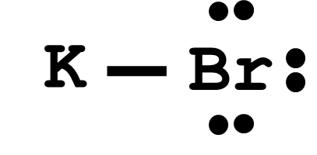
2. 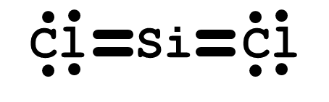
3. 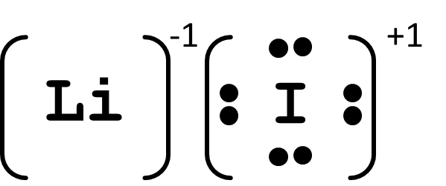
4. 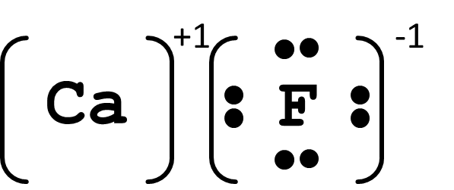
5. 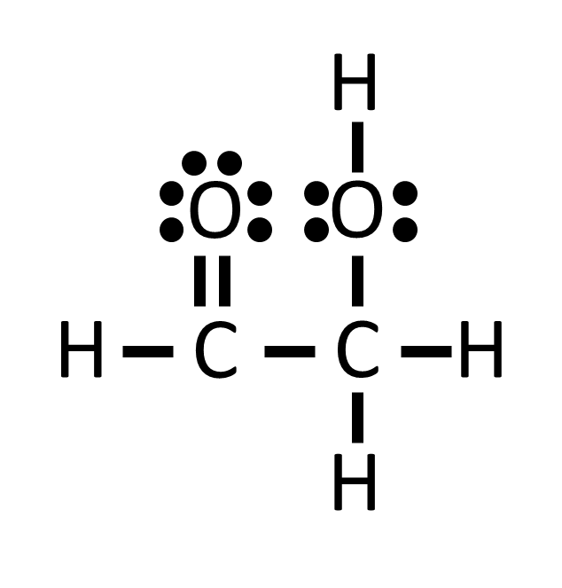
6. 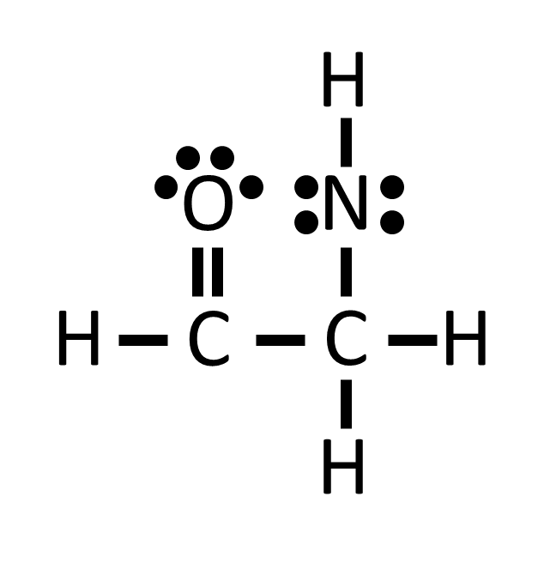
7. 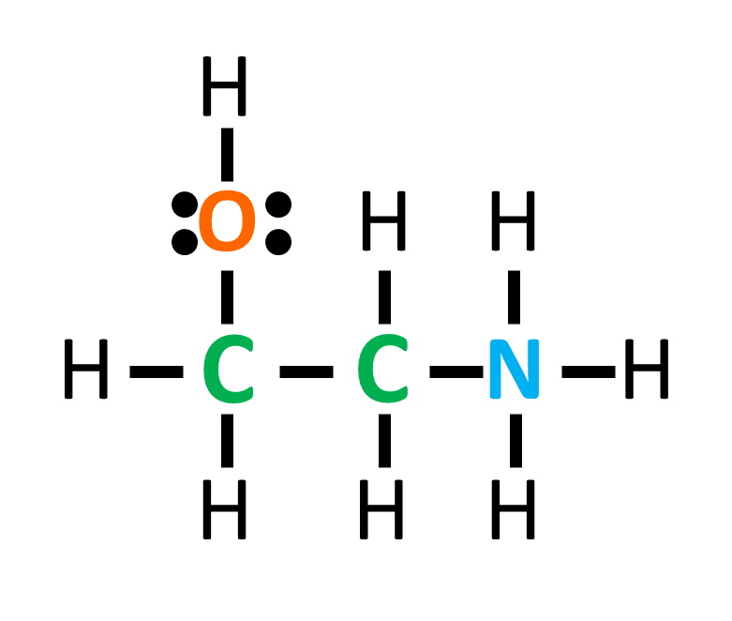
8. 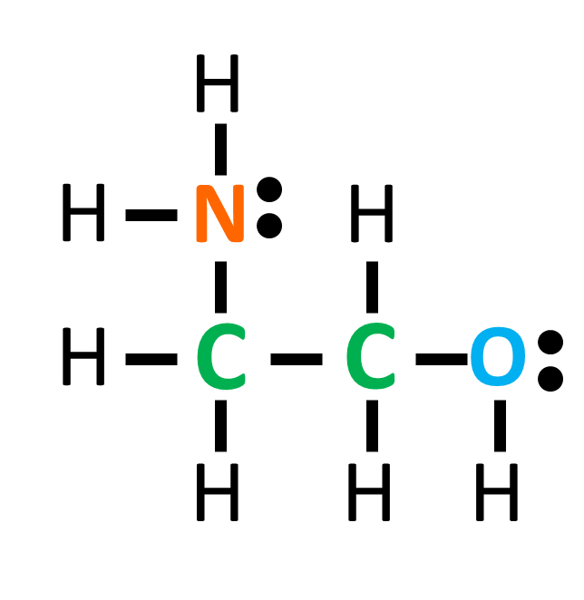
9. 